**Full** **Name**



**Self-Referral to Outpatient Physiotherapy Services**

Address

Today’s date

Date of birth

(NB this service is not for under 16s)

Your GP’s name

Your GP’s surgery

Your NHS Number

(if known)

Have you seen your GP about this problem?



Yes No When?

How long have you had this problem?

What treatment have you had for this problem before? E.g. exercise, osteopathy

Your Phone numbers – Can we leave a message at these numbers?

Phone no. (home) Yes No

Phone no. (work) Yes No

Phone no. (mobile) Yes No

Email address: Yes No

Do you require an interpreter? Yes No

Do you have any additional communication needs? Yes No

Are your symptoms worsening? Yes No

Are you able to carry out your normal activities? Yes No

Are you off work/unable to care for a dependent because of this problem? Yes No Not applicable

Please give a brief description of what the main problem is: Please shade the location of your problem on the body chart

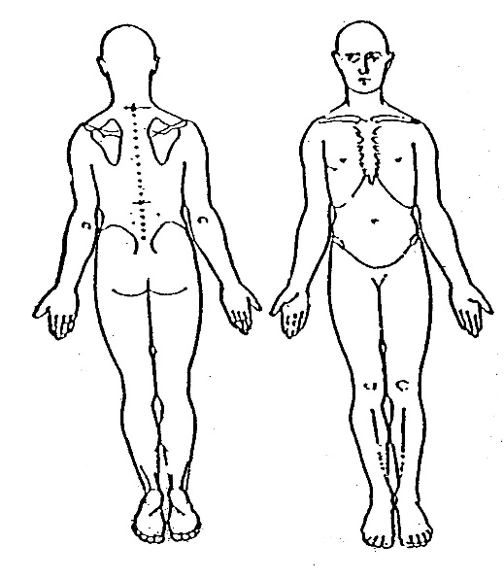

Please mark level of pain on the scale below

0 1 2 3 4 5 6 7 8 9 10

No Pain Worst Possible

Have you suddenly lost any weight without trying?

Yes No If yes, please give details

Have you had any other symptoms, such as numbness, tingling or muscle weakness?

Yes No If yes, please give details

If you have started to develop any combination of the below symptoms or you had some previously but they are worse now, seek help immediately by either contacting your GP or attending hour local accident and emergency department:

Numbness in or around your back passage or buttocks, loss of feelings/pins and needles between your inner thighs or genitals, altered feeling when using toilet paper to wipe yourself, increasing difficulty when you try to urinate, increasing difficulty when you try to stop or control your flow of urine,

loss of sensation when you pass urine, leaking urine or recent need to use pads, not knowing when your bladder is either full or empty, inability to stop

a bowel movement or leaking, loss of sensation when you pass a bowel motion, change in ability to achieve an erection or ejaculate, loss of sensation

in genitals during sexual intercourse.  
  
Please return this form to your GP practice. This form can be attached to the ‘**HealthCare Professionals Referral’** at [**www.mskdorset.nhs.uk**](http://www.mskdorset.nhs.uk)

where it will be submitted to your local NHS Musculoskeletal Physiotherapy Service.